Driver settings
Net ID – AMS Net ID of thedevice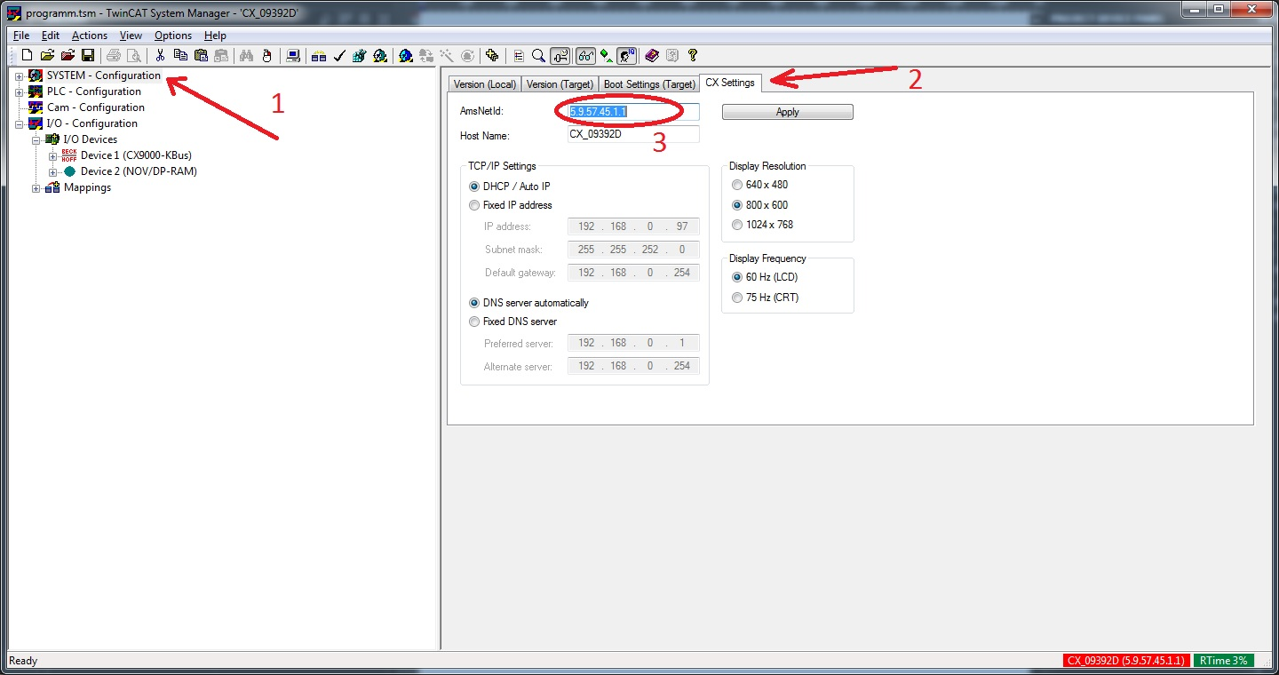
The device have to be selected as a Target device
Click System – Configuration – the CX Settings tab – AMS Net ID
How the Driver Works
You need a PLC program which runs on the device. The program has MAIN (see the image below) and GLOBAL variables.

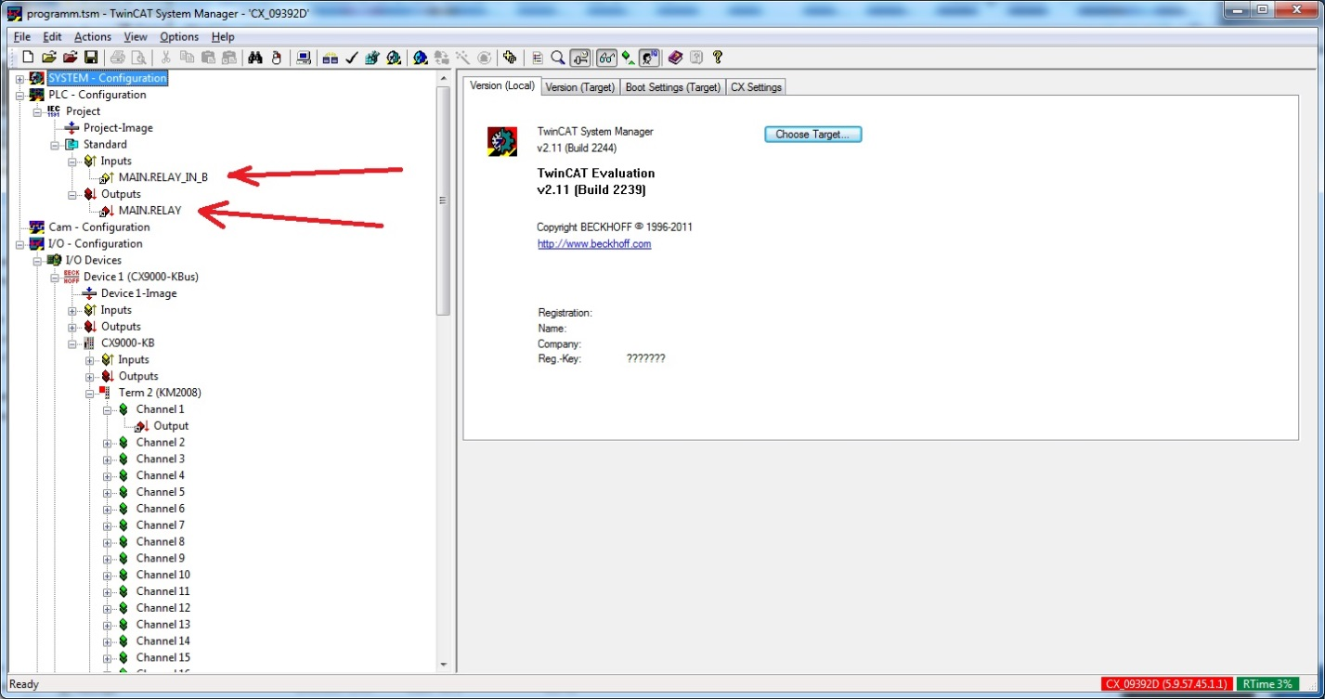
MAIN variables are linked to physical variables of the device. The driver subscribes to these variables and can manipulate them (gets the address of the memory slot where the variable is located). For example, if it is subscribed to MAIN.RELAY, then it can get feedback from the physical variable it is linked to or write some value there. It is also possible to subscribe to GLOBAL variables, but you have to use the point (.) at that. For example if you have the RELAY variable in the GLOBAL category, you need to use the following syntax to subscribe to it - .RELAY
Settings of channels and feedbacks
Target Port – the port to which the PLC variable is subscribed.
Port types
LOGGER 100
EVENT_LOGGER 110
IO 300
ADDITIONAL_TASK1 301
ADDITIONAL_TASK2 302
NC 500
PLC_RC_1 801
PLC_RC_2 811
PLC_RC_3 821
PLC_RC_4 831
CAMSHAFT_CONTR 900
SYSTEM_SERVICE 10000
SCOPE 14000

Type – the type of the variable data
PLC Var Name – the name of the PLC program variable
See the example, where you can get data in the image below
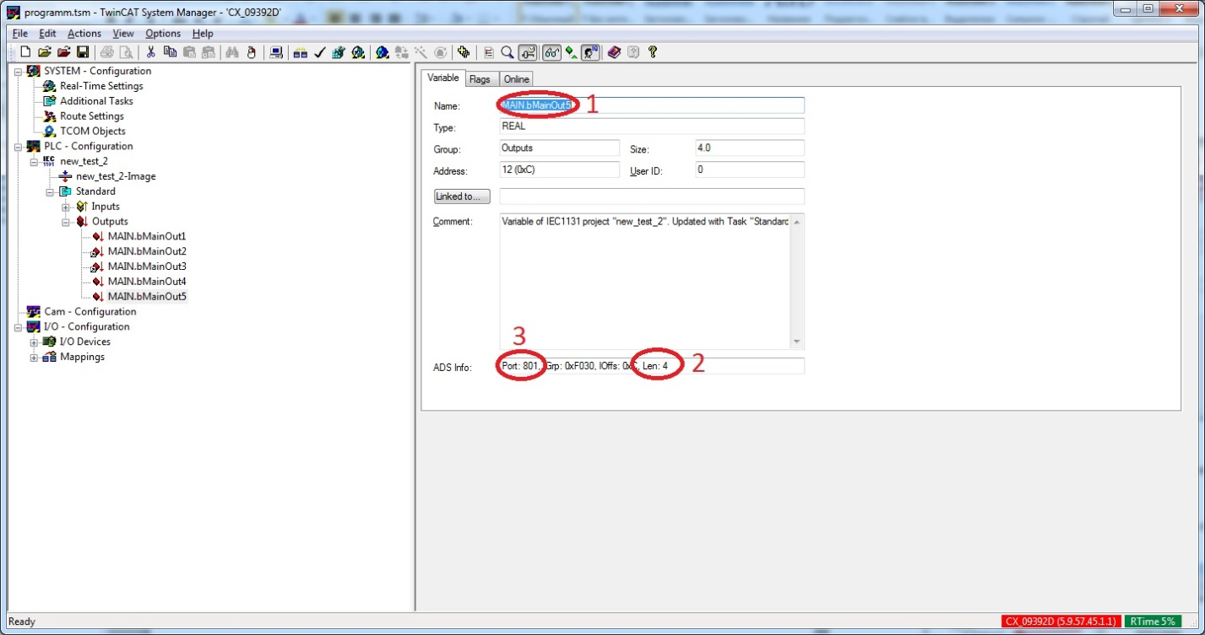
- The variable name (PLC Var Name)
- Type of the variable data (Type) (length)
The types in the editor:
- SINT – the signed data type(1 byte) Len: 1
- BOOL – (1 byte) ;
- USINT – the unsigned data type (1 byte) Len: 1
- BYTE – the character data type (1 byte) Len: 1
- INT –the signed data type (2 bytes) Len: 2
- WORD – the unsigned data type (2 bytes) Len: 2
- UINT – the unsigned data type (2 bytes) Len: 2
- DINT – the signed data type (4 bytes) Len: 4
- DWORD – the unsigned data type (4 bytes) Len: 4
- UDINT – the unsigned data type (4 bytes) Len: 4
- LINT – the signed data type (8 bytes) Len: 8
- ULINT – the unsigned data type (8 bytes) Len: 8
- LWORD – the unsigned data type (8 bytes) Len: 8
- REAL –the floating-point data type (4 bytes) Len:4
- LREAL – the floating-point data type (8 bytes) Len: 8
- STRING – the string data type (the length is set by the user) example Len: 81

- Target Port

To get access to Beckhoff from different devices you need to add your IP in the list of allowed ones:
SYSTEM - Configuration -> Route Settings -> the Static Routes tab -> Add...
Route Name (Target): any name
AmsNetId: your ip + 1.1 (example 192.168.0.10.1.1)
Transport Type: TCP/IP
Address Info: your ip
Click "Add Route" and then "Close"
You can use the Current Routes tab but after reloading of Beckhoff your IP will disappear from the list.
Also, after installing the PLC program on the device it is required to create bootproject:
In PLC Control the tab Online ->CreateBootproject

